

COMPETING VEGETATION
PEST MANAGEMENT PLAN
2020–2025

For Provincial Forests in the Peace Natural Resource District

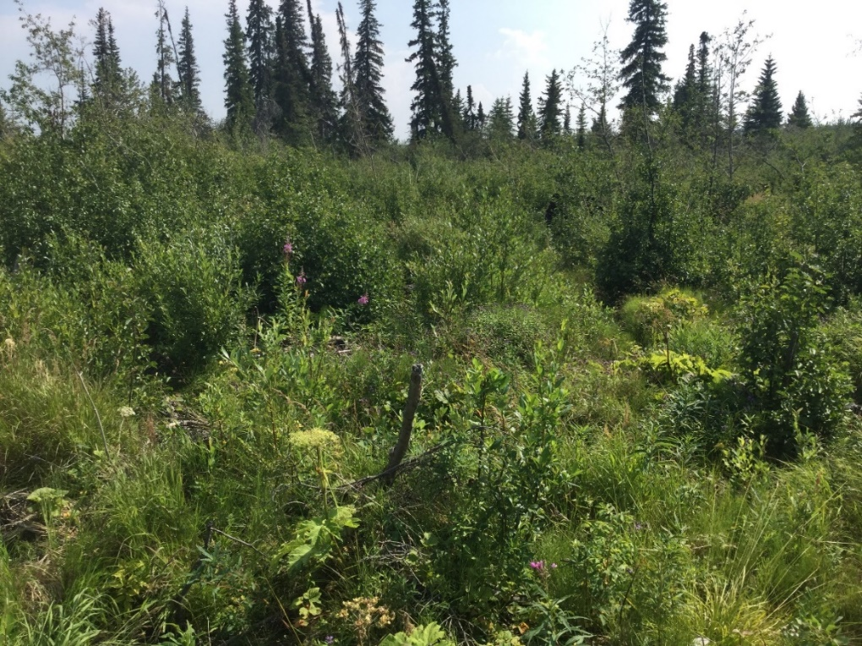

Prepared for the B.C. Ministry of Forests, Lands,
Natural Resource Operations and Rural Development,

Peace Natural Resource District,
Regional Operations Division, NE

January 21st, 2020

CONTACTS

Anyone having questions, comments, or concerns about the content of this document, or requires information about proposed activities may contact the following people:

Hannah Crisp, FIT
Stewardship Forester
Peace Natural Resource District
9000 17 Street, Dawson Creek, BC, V1G 4A4
Phone (250) 784-1200
Hannah.Crisp@gov.bc.ca

Elizabeth Hunt, RPF
Stewardship Officer
Peace Natural Resource District
9000 17 Street, Dawson Creek, BC, V1G 4A4
Phone (250) 784-1237
Elizabeth.Hunt@gov.bc.ca

Jessica Amonson, RPF
Stewardship Forester
Peace Natural Resource District
9000 17 Street, Dawson Creek, BC, V1G 4A4
Phone (250) 784-1200
Jessica.Amonson@gov.bc.ca

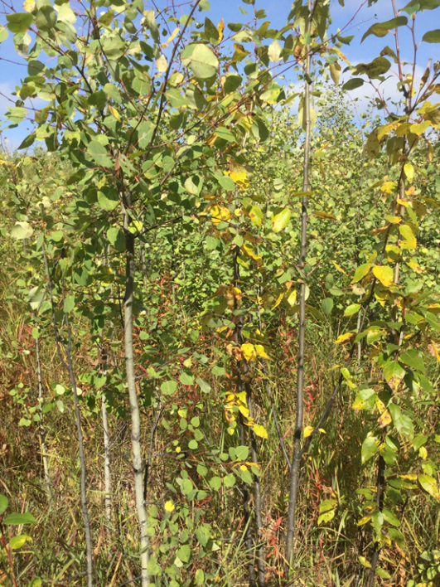

EXECUTIVE SUMMARY

The Ministry of Forests, Lands, Natural Resource Operations and Rural Development (FLNRORD), Peace Natural Resource District, Regional Operational Division submits the following Pest Management Plan (PMP) for the management of competing vegetation on Crown land in the Peace Natural Resource District (DPC). The effective period of this PMP is expected to be July 1st, 2020 through June 31st, 2025. The DPC is committed to following Integrated Pest Management Strategies described herein for vegetation management for the five-year term of this plan.
The Integrated Pest Management (IPM) framework will allow reforested and restored areas to achieve free/well-growing status within the desired time frame, to reduce potential volume losses from mortality and/or suppressed growing conditions. All IPM activities conducted under this PMP will comply with all pertinent legislation, which includes but is not limited to the Integrated Pest Management Act (IPMA) and Regulations, Forest and Range Practices Act (FRPA) and associated Forest Planning and Practices Regulation (FPPR).
This PMP applies to provincial forests within the DPC that are not part of Woodlot Licences, Timber Farm Licences, or Community Forest Agreements. The geographic boundary extends north of Fort St. John to south of Tumbler Ridge, and east of Dawson Creek to west of Chetwynd (see Appendix 1). The intention of this plan is to describe and provide guidance for integrated pest management. Annual operational plans called Notice of Intent to Treat will describe specific treatment areas.
Ministry staff have identified treatment areas that require assistance in reaching reforestation or restoration objectives following natural or human-caused disturbance within B.C. Provincial Forests. FLNRORD bodies utilizing this PMP include but are not limited to the Forests for Tomorrow Program (FFT), the Forest Carbon Initiative and the Forest Stand Management Fund.
For the purposes of this plan, a pest includes any herbaceous vegetation, shrub or deciduous complex or community that:
- Inhibits prescribed reforestation/restoration objectives;
- Hinders optimal growth and development of crop trees;
- Prevents a stand from achieving free/well growing;
- Affects an established plantation’s overall health;
- Is a species defined as an Invasive or Noxious Weed; and/or,
- When combined with snow, causes damage to a crop tree by snow press.

TABLE OF CONTENTS
1.0 Introduction…………………………………………….…….............................................................5
  - First Nations Considerations……………………………………………………………………5
  - Purpose…………………………………………………………………………………………5
  - Applications…………………………………………………………………………………….6
  - Implementation…………………………………………………………………………………6
  - Scope……………………………………………………………………………………...……7
  - 1.5 Term…………………………………………………………………………………………….7

- Integrated Pest Management Program............................................................................................7

  - Prediction and Planning………………………………………………………………..………..8
  - Prevention……………………………………………………………………………………...8
  - Monitoring and Identification of Pests…………………………………………..………….…..9

  - Consideration of Treatment Type…………………………………………………………...…11

  - Herbicide Application Rates for Vegetation Control……………………………………….......13
- Environmental Protection Measures…………………………………………………………....…..14
  - Community Watersheds and Domestic Water Intakes…………………………………..…..…14
  - Food Plants……………………………………………………………………………..…......15
  - Fisheries Resources, Riparian Areas and Wildlife Features…………………………………......15

  - Wildlife Values………………………………………………………………………….……..16

  - Species at Risk……………………………………………………………………………..…..16
- Operational Standards…………………………………………………………………………….….17
  - Boundary Layout Procedures…………………………………………………………….……17
  - Final Pre-treatment Reconnaissance…………………………………………………….……..18
  - Safety During Operations……………………………………………………….………..……18
  - Handling Practices…………………………………………………………………….………18

  - Mixing Loading and Applying Herbicide…………………………………………………..…..18

  - Safe Disposal of Empty Herbicide Containers and Unused Herbicides…………………..……19

  - Herbicide Spill Response………………………………………………………………...….…20

  - Equipment Maintenance and Calibration……………………………………………….…..…21

  - Pesticide Treatment Signs ……………………………………………………………….…....21
  - Site and Weather Monitoring Procedures……………………………………………….……..22
  - Pesticide Use Record and Annual Report Form………………………………………….……22
  - Annual Notice of Intent to Treat……………………………………………………………..22
  - Consultation………………………………………………………………………………….22
- References .………………………………………………………………………………..………......23
Appendix 1: Map of PMP Geographic Boundaries ……………………………………………..….……..24
Appendix 2: Detailed Site Assessment ………………………………………………………….……..….25

LIST OF TABLES
Table 1: Reforestation and Restoration Programs within the scope of this plan …………………….…..7

Table 2: Benefits and Limitations of Treatment Methods ……………………………………………...12
Table 3: Herbicides ……………………………………………………………………………………14
Table 4: Proposed Maximum Application Rates for Vision Max …………………………………...….14
Table 5: Pesticide Free Zones, Buffers and No Treatment Zones ……………………………………..15
Table 6: Potential Red and Blue Listed Species within the DPC ………………………………………..17

ACRONYMS
DPC – Peace Natural Resource District
DSA – Detailed Site Assessment
FFT – Forests for Tomorrow
FLNRORD – Ministry of Forests, Lands, Natural Resource Operations and Rural Development
FPPR – Forest Planning and Practices Regulations
IPM – Integrated Pest Management
IPMA – Integrated Pest Management Act
MOE – Ministry of Environment
NIT – Notice of Intent to Treat
PMP – Pest Management Plan

- INTRODUCTION
The Northeast Region of B.C. is simultaneously a valuable corner of boreal forest ecosystem and a significant economic generator. The region is rich in oil, gas and mineral deposits as well as merchantable timber and agriculture. As a result, resource extraction industries have made a noticeable indent on the Northeast forested landscape. Linear features such as roads, seismic lines and pipelines have fragmented habitats, and significantly altered wildlife interactions and movements. Additionally, fire suppression, subsequent fuel build-up and recent temperature changes due to Climate Change have increased the frequency and severity of wildfires in the entire province, including the Northeast Region. Novel fire regimes threaten wildlife habitat and timber supply. More frequent and severe wildfire occurrence also shifts the boreal forest carbon balance towards a source rather than a sink.
The Province of B.C. is committed to ameliorating the balance between economic activities and other forest values—as outlined in the Forest Planning and Practices Regulations (FPPR)—in relation to soils, biodiversity, wildlife, cultural heritage resources, visual quality and riparian ecosystems. FLNRORD is also committed to managing forest carbon, as outlined in the Forest Carbon Strategy 2016-2020. As a result, FLNRORD has several restoration and reforestation initiatives aimed at regenerating timber supply and other forest values on previously productive areas and/or areas impacted by catastrophic disturbance. To ensure regeneration success, Ministry staff may prescribe herbicide treatments to prepare sites prior to planting and to reduce the vigour of competing vegetation.

1.1 FIRST NATIONS CONSIDERATIONS
This plan includes the traditional territories of many First Nation communities. To support ongoing reconciliation, FLNRORD looks forward to collaborating with First Nations to ensure that their interests, cultural practices, and traditional knowledge are considered throughout the duration of this plan. FLNRORD will attempt to address specific concerns on an opening basis through the annual notification process sent out before each brushing season. Site specific areas of interest will be addressed at that time and attempts made to reach solutions that meet the needs of all parties.

1.2 PURPOSE
The purpose of this Pest Management Plan (PMP) is to implement a proactive program of identification, prevention, and monitoring of pests (herbs, shrubs and deciduous tree competition) that impede restoration and reforestation objectives on provincial forested Crown lands in the Peace Natural Resource District (DPC). Section 7 (1) of the Integrated Pest Management Act states: “A person must not use or authorize the use of a prescribed pesticide or class of pesticides, or use a pesticide for a prescribed use, unless […] a pest management plan has been prepared that complies with the regulations […]”. This legislation ensures herbicide users implement an Integrated Pest Management (IPM) program: a combination of pest-control approaches, including prevention. This plan outlines the strategies used by FLNRORD DPC staff to manage competing vegetation using IPM, the standards under which it will operate, and describes measures to protect human health and the environment.
The objectives of this PMP are as follows:
- To establish free/well growing crop trees on a forest opening in a cost-effective manner with full consideration of human safety and social, environmental, and cultural values.
- To control competing vegetation or brush encroachment of young tree seedlings.
- To establish a clear decision-making process that sets standards for timely and effective treatments.
- To promote the use of integrated vegetation management practices and strategies that minimizes vegetation pest problems and reduces the need for the use of herbicides.
- To provide an open forum for First Nations and public participation concerning PMP development and content.

1.3 APPLICATIONS
Reforestation

The Land Based Investment Strategy (LBIS) is a FLNRORD program that guides conservation and resource-management investment targets within BC. The most recent LBIS report (Ministry of Forests, Lands and Natural Resource Operations 2015) prioritized investment in tree planting on Mountain Pine Beetle (MPB) and wildfire impacted lands. Investment for these reforestation projects is fed through the Forests for Tomorrow Program. One of the implementation priorities identified in the 2015 report was to “maintain adequate growth rates on existing government-funded land-based investments through vegetation management”. It is our responsibility —when using investment funds for tree planting purposes—to properly manage for crop tree endurance using vegetation management treatments whenever necessary.

Ministry staff will be using funds from the Forest Stand Management Fund, Forest Carbon Initiative and the Forests For Tomorrow Program to reforest areas affected by wildfire and MPB. Priority areas include Free Growing cut-blocks that lost significant amounts of stock trees due to wildfire and areas of salvage logged MPB impacted stands. These sites will be managed for carbon (via high planting densities and strategic species selection) and for timber supply (via silviculture of preferred timber species). Replanting may also occur in wildfire-affected areas adjacent to cut-block boundaries. These areas may have lower-site index, in which case tree planting would be for carbon sequestration and forest habitat purposes. We will prescribe pre-planting herbicide for site-preparation on sites where brush obstructs plant able spots. After crop-tree establishment, brushing treatments may be prescribed in areas where competing vegetation threatens crop-tree health and productivity.

Restoration

Restoration priority will be determined based on characteristics such as accessibility, productivity (site index) and special management (wildlife habitat, old growth management areas etc.). The Society for Ecosystem Restoration in Northern BC (SERN) has identified suitable restoration areas based on the above characteristics (Campbell et al. 2018). Ministry staff will consider these recommendations, as well as the Northeast Regional investment priorities to maximize recovery and value of forest resources; reduce risk of wildfire impacts to remaining timber inventory, communities and critical infrastructure; increase carbon sequestration; and improve ecosystem health (particularly wildlife habitat) and resiliency.

1.4 IMPLEMENTATION

This PMP will be used by all FLNRORD departments and programs that manage competing vegetation on provincial forests in the above-described areas. This PMP applies, but is not limited to, the programs and initiatives shown in Table 1.

Table 1. Reforestation and Restoration Programs within the scope of this plan

Program | Value(s) | Description | Role of PMP | Funding
Silviculture of Provincial Forests – Stewardship department of FLNRORD | Timber supply, carbon sequestration | Reforestation in free-growing plantations or other provincial forest areas affected by disturbance e.g. wildfire, forest pathogens or pests.  Areas where licensees no longer/never had legally binding obligations to reforest. | IPM used as a silvicultural tool to suppress competing vegetation, so that planted seedlings can efficiently achieve establishment and attain free/well growing status. | Forests for Tomorrow, Forest Carbon Initiative
Small Scale Salvage Reforestation | Government obligation, Timber supply | Areas where as per the Forest Planning and Practices Regulation S.46 (1) and (3), the government has a legal obligation to reforest Forest Licence to Cuts: Salvage harvesting | Same as above | Forest Stand Management Fund

1.5 SCOPE

This PMP applies to provincial forests within the Peace Natural Resource District (DPC) in the Northeast Region of British Columbia (see Appendix 1). The FLNRORD office for DPC resides in Dawson Creek. Treatment areas will include provincial forests subject to reforestation or restoration programs following disturbances such as forestry, oil and gas development, wildfire and forest pests and pathogens. This PMP does not cover provincial forests within Tree Farm Licences, Woodlot Licences or Community Forests, nor does it cover protected areas and parks.

1.6 TERM
The expected effective term of this PMP will be July 1st, 2020 through June 31st, 2025 as confirmed by the BC Ministry of Environment (MOE) registration of this PMP.

2.0 THE INTEGRATED PEST MANAGEMENT PROGRAM
According to the Integrated Pest Management Act, integrated pest management includes (a) planning and prevention, (b) identifying pests, (c) monitoring populations, (d) using injury thresholds, (e) supressing pest populations and (f) evaluating the effectiveness of treatments. By following this proactive regime, pesticide applicators can use the minimum treatment amount required to obtain the desired results. Consequently, land managers may reduce cultural and environmental risks associated with pest management treatments.
The focus of this IPM strategy is the long-term prevention of crop tree damage or growth impedance from pests using silviculture management techniques such as planting, manual brushing, chemical and/or biological control measures. Herbicides are used only after comparing all available options and minimizing risks to human health, negative impacts to non-target organisms and the environment.

2.1 PREDICTION AND PLANNING

Before zooming into specific treatment areas, we must first address overall landscape restoration and reforestation objectives. Our restoration or reforestation objectives depend on a site’s (1) pre-disturbance characteristics and (2) long-term purpose. For example, if a free-growing plantation succumbs to wildfire then we may wish to restore the original planted conifer composition and control competing vegetation to maximize coniferous timber supply.

Site-specific planning can occur from when a disturbance creates a forest opening, or a pre-existing opening is chosen for reforestation/restoration. Knowledge of how vegetation responds to disturbance on a given ecotype can be used to predict a potential pest problem and prescribe mitigating measures. These mitigating measures might include site preparation, species selection, stock type selection, planting timing and alteration of stocking standards. The underlying goal of competitive vegetation management is to ensure the survival of invested crop trees and to achieve the desired ecosystem composition and stocking standards.

No treatment may be required if the desired ecosystem composition accepts deciduous species in a mixed-wood regeneration scenario. Model projections have shown that mixed stands have greater merchantable volume (Kabzems 2015), if mixed-wood techniques are implemented proactively. Allowing for a diversity of forest compositions to regenerate improves landscape-level ecosystem diversity; which in turn maintains a diversity of wildlife habitats, ecosystem functions and processes, and merchantable timber species. In some cases, it may be appropriate to alter stocking standards and allow for natural regeneration to accompany planting.

2.2 PREVENTION

A post disturbance walkthrough or silviculture survey will identify areas where vegetation is expected to become a concern. This assessment will provide guidance on the need for site preparation, planting, brushing and the need for further assessments. We will use the following preventative measures to manage competitive vegetation:
- Early identification of brush prone sites – BEC zone classification and site series known to have high brush hazards are identified in the silviculture survey, and appropriate treatment regimes are implemented.
- Use of improved seed – seed of the highest genetic worth available for the area (Class A Seed) is used to grow seedlings for planting and fill planting activities where available. Seedlings grown from improved seed show faster growth than those grown from wild seed, thereby improving their ability to compete with encroaching vegetation.
- Selection of appropriate species and provenances – ecological classification will provide guidelines for species and provenance selection to maximize seedling performance and minimize the need for brushing treatments.
- Selection of appropriate stock type – the physiological characteristics seedlings possess have a significant impact on seedling establishment and capacity to compete against encroaching vegetation. For example, small stock types may be appropriate for use on sites with a low competition hazard or other limiting factors, while larger stock types may be appropriate on sites with high competition hazard.
- Minimizing regeneration delay – Seedlings that are quickly established are more likely to compete successfully with problematic vegetation. Seedlings should be planted as soon as possible following harvesting, especially on sites with high brush hazard.
- Maximizing seedling performance – seedlings that are planted in the best microsite possible and that remain undamaged during the planting process are more likely to compete successfully with problematic vegetation. Guidelines on stock handling to avoid seedling damage and optimizing the quality of planting microsites are followed during planting activities.
- Increased planting density - planting densities will be managed to reflect the influence of site conditions such as brush, natural regeneration, and anticipated seedling mortality.
- Site Preparation – site preparation will be conducted, where appropriate, to improve microsites for newly established seedlings by reducing or rearranging slash, ameliorating adverse forest floor, soil, above and below ground vegetation structure, or other site biotic factors.

2.3 MONITORING & IDENTIFICATION OF PESTS

Monitoring will take place in the form of periodic silviculture surveys that follow procedures outlined in the Silviculture Survey Procedures Manual.
The data and information collected during silviculture surveys includes but is not limited to the following: distribution and percent cover of the vegetation, height of the crop trees, height of the brush species, type of brush species, and the affect the brush is having on the crop trees. The type of survey conducted will depend on a site’s silvicultural stage.

For the purposes of this pest management plan, silviculture surveys will record competing vegetation within the following three categories:

- Herbaceous plants (vegetation community A): Herbaceous species predominately compete with newly planted seedlings for light, moisture and nutrients. They commonly contribute to vegetation and snow press. Species found within the DPC include but are not limited to: fireweed (Epilobium angustifolium), grass (Calamagrostis spp.), horsetail (Equisetum spp.), and lady fern (Dryopteris spp.). Herbacious competition is a concern for smaller conifer seedlings in the establishment stage when the vegetation at maturity is taller than the seedling within 1m of the conifer stem. Brush hazard depends on the BEC classification of the site, with wetter and richer sites having potential for higher competition with crop trees.

- Shrubs (vegetation community B): Shrubs can be divided into two categories:
- Low shrubs: woody plants that typically grow to be less than 1.5 metres in height. Species include but are not limited to: thimbleberry (Rubus parviflorus), black twinberry (Lonicera involucrata), white flowering rhododendron (Rhododendron albiflorum), prickly rose (Rosa acicularis), and red raspberry (Rubus idaeus). Low shrubs compete with conifer seedlings at the establishment stage and when the shrub growth rate is faster than that of the seedling.

High shrubs: typically grow to heights taller than 1.5 metres. Species include but are not limited to: alder (Alnus spp.) and willow (Salix spp.). Alder is commonly found in mature stands within the DPC. After harvest, alder can potentially be a significant competitive species depending on the ecology, the distribution and density throughout the site at establishment and free growing stages.

- Broadleaf trees (vegetation community C): Species include but are not limited to: trembling aspen (Populus tremuloides), balsam poplar (Populus balsamifera), and paper birch (Betula papyrifera). Many forest stands in the DPC have a minor component of mature aspen. A moderate to very high brush hazard from aspen may occur after harvesting stands with a component of aspen due to root suckering.

For more information about plant species and ecology in the Northeast, please refer to ‘Plants of Northern B.C.’ (Mackinnon et al. 1999) and ‘Rare Native Vascular Plants of British Columbia’ (Douglas et al. 1998).

Preliminary Surveys

Once a disturbance-induced opening is identified, certified surveyors will conduct a stocking/plantability survey to assess how the disturbance affected existing crop trees and the density of incoming competing vegetation. Surveyors will also assess potential return on investment by measuring site characteristics like site index, slope, accessibility, estimated cost etc.
Site preparation treatments considered will be mechanical site preparation, manual brushing, fire and herbicide. If required, the surveyors will compose a planting prescription, including suggestions for knock down of standing dead stems for safety.
Herbicide site preparation will only be prescribed where herbaceous, shrub and broadleaf (deciduous) complexes or communities obstruct plantable spots, is a species defined as an invasive or noxious weed, and other methods of site preparation are not feasible.

Recurrent Surveys

Two years after planting, certified surveyors will conduct a Regeneration Survey to check survival and health of planted stock trees and prescribe fill planting or brushing treatments if necessary. After another three to five years, surveyors will conduct stocking surveys to determine whether further brushing treatments are required for competing vegetation. Once crop trees reach free-growing height (about 10-20 years after planting), surveyors will conduct free-growing surveys. Surveyors may prescribe herbicide treatments at this stage when competing vegetation prevents the stand from achieving free-growing status.
Detailed Site Assessment
When a survey recommends treatment, a Detailed Site Assessment (DSA) will be completed less than 18 months before treatment. Information collected as part of the DSA includes tree inventory, site history and characteristics, water and wildlife features, competing vegetation details, and condition of crop trees. The surveyor will also watch for evidence of cultural significance to First Nations such as campsites, cabins, prayer flags and sweat lodges. See template in Appendix 2.

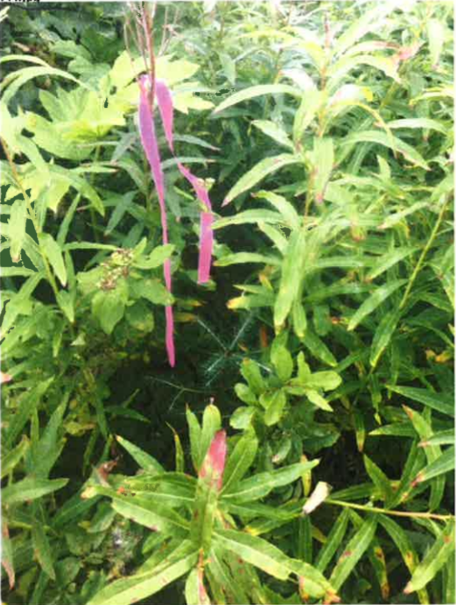
Project Supervisor and Monitors Minimum Qualifications

All herbicide treatments carried out under this PMP will be conducted under the direct supervision of either a Ministry Representative, or an appointed contractor. All herbicide treatments will be conducted or directed, and/or monitored by an individual who holds a valid Pesticide Applicator Certificate – Forestry General. Training records will be kept and made available for all staff handling or utilizing pesticides including Assistant Applicators as per IPMA and IPMR.

Post Treatment Evaluation
An evaluation will be performed in the year after completion of treatment to assess efficacy of treatment, crop tree condition and impact on non-target organisms. The purpose of the post treatment monitoring is to provide continuous improvement to the Integrated Pest Management program by making any necessary changes such to treatment thresholds, methods and application timing. Compliance with pesticide free zones and boundaries will be checked and any non-compliance reported to the Ministry of Environment. The evaluation will also determine the need for any follow up treatment.

2.4 CONSIDERATION OF TREATMENT TYPE
Treatment with lowest impact to cultural and environmental values will be selected in consideration with treatment cost, access, site factors and target vegetation characteristics. FLNRORD is committed to reconciliation with First Nations. The annual NIT will contain information on specific treatment areas and this plan will be shared with First Nations to come up with a plan that addresses concerns. When specific information indicates that there is infringement on aboriginal rights, certain treatments may be considered unsuitable. A buffer or NTZ may be implemented or an alternative treatment chosen. Specific treatment factors considered:

Target Species Height: Backpack foliar treatments are typically not appropriate once the height of the target brush species approaches 2 metres in height. Sheep grazing will similarly be constrained by the ability of sheep to reach the foliage.

Target Species Diameter: While virtually any deciduous tree stem can be girdled, there are upper and lower diameter limits beyond which treatment becomes impractical. These will vary somewhat depending on the species of tree and the type of girdling tool being used. In general, diameters less than approximately 3 cm, or greater than 20 cm, are not suitable for treatment. Manual treatments will have an upper practical limit as diameters approach 10 cm.
Target Species Distribution: Broadcast foliar treatments are not appropriate if the target brush is distributed only in discrete clumps. Discretionary treatments are not generally appropriate if the target brush is uniformly distributed over the treatment unit.

Physical Impediments to Treatment: Large numbers of overhead obstacles such as residual trees can preclude aerial treatments. Steep slopes and heavy slash loading can make ground-based treatments such as backpack, manual, mechanical and sheep grazing impractical.
Degree of Constraint of Treatment Due to Required Buffering etc.: Blocks with many features that require buffering may be impractical to treat chemically. Pesticide Free Zones (PFZ), No Treatment Zones (NTZ), and Buffers may be required for resource values such as water bodies, wetlands, roads, etc. Some highly constrained units may have little area left treatable once the chemical buffers are in place.
Target Species-Crop Tree Protection Conflict: Some brush species such as cow parsnip may no longer be susceptible to chemical treatment by the time the crop trees have hardened off sufficiently to avoid chemical damage. This incompatibility may be consistent every year, or it may only apply in certain years when a wet summer has slowed conifer hardening off (lamas growth) or when early frosts cause succulent target species to wilt.
Special Wildlife Features: Special wildlife features may be identified within some units that will constrain treatment options. Heavy browsing might reduce the need for brushing in an area that has little alternative browse available. Manual and mechanical treatments might be restricted when the slash loads likely to result from the treatment could obstruct a heavily use game trail. Sheep grazing has been opposed by MOE representatives in high grizzly bear use areas and in areas with wild sheep populations, the practice is not recommended.

Competing Interests: Certain features of a proposed treatment unit might indicate that chemical treatment could result in an unacceptable risk of creating conflict with members of the general public, aboriginal groups, local residents or other stakeholders. For example, proximity to a residence might result in the choice of specific treatments.
Potential Damage to Crop Trees: Certain treatments may expose the crop trees in a unit to unacceptable levels of risk of damage. For example, crop trees that have developed under a thick aspen canopy often become spindly. Treatments that remove the surrounding stems suddenly can result in toppling of the crop trees or causing sun scald. Aerial spraying or girdling may be preferred in such cases. Alternately, manual treatments may be inappropriate where heavy slash loading can occur, or palatability of target vegetation can be an issue when considering sheep grazing.

Table 2. Benefits and Limitations of Treatment Methods
Benefits | Limitations
Manual Girdling, Snap/Hinge, Bend & Break
Can be used selectively, no use of herbicides, tools are inexpensive, girdling is possible for taller deciduous where other methods may not be, and possible to perform on steep terrain | May require multiple entries due to re sprouting of target vegetation, creates slash, high labour cost, can cause repetitive strain injuries in workers, specific diameter requirements for target vegetation.
Manual Brushing and Weeding
Can be used selectively and in riparian and other pesticide free zones, no use of herbicide | May require multiple entries due to re sprouting of target vegetation, high cost, safety concerns with used of brush saws as well as repetitive strain injuries, specific diameter requirements for target vegetation
Brush Mats
Can be used selectively and in riparian and other pesticide free zones, no use of herbicide, and brush control for multiple seasons. If biodegradable brush mats are used the environmental footprint is reduced, as well as providing moisture regulation | High product as well as labour cost, not suitable in steep terrain due to risk of mats sliding onto seedlings, may create habitat for voles, not suitable for shrub or deciduous tree competition
Sheep Grazing
Can be used selectively and in riparian and other pesticide free zones, no use of herbicide | May require multiple entries due to re sprouting, only effective on specific vegetation, high cost, requires road accessibility, flat terrain and low slash levels. Sheep can damage crop trees, risk of disease spreading to wild sheep, and risk of predation
Mechanical Site Preparation
Can be used selectively and in riparian and other pesticide free zones, no use of herbicide, can raise soil temperature and provide raised microsites | Brush control is temporary, risk of soil disturbance, expensive, requires access by heavy equipment, limited to certain site conditions
Prescribed Burning
Effective site preparation for seedlings, no use of herbicide and mimics natural disturbance | Specific weather conditions required, risk of escaped fire, cannot be used once conifer seedlings are established, brush control is temporary
Aerial Herbicide
Effective vegetation control for several years; low cost; possible to treat steep and inaccessible areas; effective on most types of competing vegetation, and less handling of herbicide than backpack methods | Lower acceptance, less selective than other methods, limited by the presence of mature trees and use in riparian areas and sensitive wildlife or cultural use areas
Backpack Herbicide
Effective vegetation control for several years, low cost compared to manual treatments, ability to be selective in treatment, can treat areas with residual mature trees, effective on most types of competing vegetation, requires a smaller buffer zone around riparian and sensitive areas | Lower acceptance, higher cost than aerial spray method, more handling of herbicide by workers, cannot be used on taller vegetation
Hack & Squirt, Basal Bark, and Cut Stump Herbicide
Effective vegetation control for several years, more selective than aerial, smaller buffer zone required, effective on larger vegetation compared to backpack, uses less herbicide than aerial or backpack | Lower acceptance, higher cost than aerial or backpack spray method, more handling of herbicide by workers, safety concerns when using a brush saw

Other factors such as treatment windows, time required to treat an area, administrative load, priority of treatment based on risk of crop tree mortality, and efficacy are weighed separately from above process. New pesticides and treatment technology will be researched throughout the life of this PMP. Final treatment prescriptions are then verified in the field by experienced Ministry staff to ensure the most appropriate treatment is utilized.

2.5 HERBICIDE APPLICATION RATES FOR VEGETATION CONTROL
FLNRORD commits to using the lowest treatment rates that will provide effective control of competing vegetation. Herbicides to be used for brush control under this PMP are listed in Table 3. The herbicides listed in this table are registered for forestry use under the Pesticide control Products Act. Glyphosate is chosen because of its low toxicity and effectiveness in controlling forest vegetation.

Table 3. Herbicides & Biological Control Agents *

Trade name |  | Active ingredient | Pcp no.
Vision® |  | Glyphosate 35.6% | 19899
Glysil Forestry® |  | Glyphosate 35.6% | 26884
Release® |  | Triclopyr 48% | 22093
Weedmaster® |  | Glyphosate 35.6% | 29009
Vision(Max)® |  | Glyphosate 54.0% | 27736
Chontrol Peat Paste * |  | Chontrostereum purpureum 0.67% | 29293

Table 4. Proposed Maximum Application rates for Vision Max (Preferred Herbicide). Kg Active Ingredient (A.I.)/ha based on Weedmaster and equivalent rates for VisionMax.

Plant Species Treated | Weedmaster (35.6%) |  |  | VisionMax (54%)
Plant Species Treated | L/ha | Kg A.I./ha |  | L/ha | Kg A.I./ha
Twin Berry | 3.5 | 1.246 |  | 2.3 | 1.242
Aspen, Birch, Rose, Cottonwood | 4.5 | 1.602 |  | 3.0 | 1.620
Elderberry, Willow, Firewood, Horsetail, Thimbleberry, Raspberry | 5.0 | 1.78 |  | 3.3 | 1.782
Bluejoint Grass, Alder, White Flowered Rhododendron, Azalea, Bracken fern, Lady Fern | 6.0 | 2.136 |  | 4.0 | 2.160

If proposed application rates are greater than the listed maximums, a rationale will be documented and provided in the Notice of Intent to Treat (NIT), as well as kept on file. For chemical site preparation activities, application rates shall be consistent with manufacturers suggested application rates found on the label. Proposed application rates may never exceed rates on the product label. Where vegetation complexes exist, more than one target species may be identified. In these cases, the maximum application rate will be based on the target species with the highest application rate. Discretion will be used to ensure that a target species with low percent coverage and higher application rate is not used in determining the application rate.

3.0 ENVIRONMENTAL PROTECTION MEASURES
3.1 COMMUNITY WATERSHEDS AND DOMESTIC WATER INTAKES
There are no known watersheds currently classified as “community watersheds” within the boundaries of this PMP. A Pesticide Free Zone (PFZ) will be established around any community watersheds that may be developed during the term of this PMP to ensure that the integrity of the watershed is maintained. The area of the PFZ will comply with the standards set at that time.
There are no known domestic or agricultural water wells or water supply intakes that occur within the boundaries of the Peace Natural Resource District, however, if during the term of this PMP, one is established, a 30 metre NTZ will be designated around the well or intake, pursuant to Section 71 of the IPMR.
3.2 FOOD PLANTS

First Nations and stakeholders use berry plants and other special plants for food, medicinal and cultural purposes. As part of the public review and consultation process for this PMP and annual NITs, FLNRORD will attempt to learn of important berry-picking and medicinal plant harvest areas. Where proposed treatment areas are identified as containing food or medicinal plants intended for human consumption, FLNRORD will prevent exposure to herbicides by using non-herbicide treatments or avoidance of treatment. All blocks treated with herbicides will have signs at entrances as required by the IPM regulations.

3.3 FISHERIES RESOURCES, RIPARIAN AREAS AND WILDLIFE FEATURES
Buffer Determination

Riparian and Wildlife features are assessed through Detailed Site Assessment (DSA’s) and pre-treatment inspections by Ministry staff, during treatment layout, and the final pre-treatment reconnaissance. In keeping with mandates outlined in all forest plans and relevant legislation, identified habitat shall be protected with a series of measures including appropriate Pesticide Free Zones (PFZ’s), buffers & No Treatment Zones (NTZ’s) as described in Table 5.

Table 5. Pesticide Free Zones (PFZ), Buffers and No Treatment Zones (NTZ) for Riparian & Wildlife Features

Area of Concern | Application Method | PFZ (m) | Buffer (m) | NTZ (m)
Classified S1-S6 Streams, L1, L2, L3, L4 Lakes,  W1-W3, W5 Wetlands | Aerial Conventional  Aerial (low drift delivery system) Backpack (Broadcast)  Backpack (Directed Foliar) Backpack Cone  Hack and Squirt  Cut Stump  Backpack Basal | 10  10  10  10  10  10  10  10 | 10  5  5  5  5  5  5  2
Dry S5, S6, NCD’s, Temporary free-standing body of water | Aerial (low drift delivery system) Backpack Ground  Backpack Cone  Hack and Squirt  Cut Stump  Backpack Basal | N/A  N/A  N/A  N/A  N/A  10 | N/A  N/A  N/A  N/A  N/A  2
Temporary free-standing body of water >25 m² * | All application methods | High Water Mark | N/A
Domestic water intake | Any |  |  | 30
Active beaver lodge/pond/dam | Aerial |  |  | 50
Raptor nest | All (except manual) |  |  | 100
Significant Mineral Licks | All | 100 | 5
*non fish-bearing, does not drain into a fish-bearing waterbody and is not a classified wetland or a wildlife habitat feature

Glyphosate Buffers

As per Section 75(3) of the Integrated Pest Management Regulation, when glyphosate is being used, the buffer can be reduced to 2 m along or around the body of water or classified wetland if the following conditions are met:

- The body of water or classified wetland is not fish-bearing at any time of the year; and
- Selective application methods are used between 2m and 10m above the high-water mark.

Glyphosate Buffer Exemption

As per Section 75(4) of the Integrated Pest Management Regulation, when glyphosate is being used, a buffer may not be required if the following conditions are met:

- A temporary free-standing body of water,
- Not a classified wetland nor a wildlife habitat feature,
- Not fish bearing and does not drain into a fish bearing body of water within 100m, and
- No glyphosate is applied below the high-water mark

3.4 WILDLIFE VALUES

The DPC has many important and diverse habitats for mammal, bird, amphibian, and fish species. Wildlife shall be managed according to current and evolving biodiversity guidelines and all standards as stated within legislation will be followed. Staff conducting DSA’s will receive sufficient training to identify and assess threats to wildlife and habitat and provide recommendations to avoid unreasonable adverse effects.

All wildlife values and critical habitats identified in higher level plans, or while conducting fieldwork, or through the consultation/referral process shall be considered prior to carrying out any treatments under this PMP.

Examples of treatment objectives tailored to suit wildlife habitat needs include:
- pesticide free zones,
- pesticide dosage thresholds for areas of significant value,
- spot treatments,
- manual treatments, and
- where feasible, the retention of ungulate browse species such as willow and red osier dogwood.

Active beaver lodges, ponds and dams; raptor nests; carnivore dens and significant mineral licks will be buffered as detailed in Table 5.

A significant mineral lick means a naturally occurring mineral lick that is used at least annually by one or more species as evidenced by well-established trails or braided trail systems leading to the mineral lick site, extensive excavation or trampling, and/or teeth marks, pellets, tracks, and hair.
This definition is not applicable where the mineral lick has been created by a human activity. The buffer will include at least two primary trails leading to the lick.

3.5 SPECIES AT RISK

As per the B.C. Conservation Data Centre, there are currently four red listed species within the DPC: Caribou, Northern Myotis, Bay Breasted Warbler, and Nelson’s sparrow. Additionally, there are more than a dozen blue listed species with possible ranges within the DPC (see Table 6). Critical Habitats for the red listed species have been mapped. Ungulate winter range for Caribou has been mapped, and polygons have been flagged as either conditional harvest zones or no harvest zones (Data BC).

Table 6. Potential red and blue listed species with habitat and/or ranges within the DPC
as per the B.C. Conservation Data Centre in 2020:

Red Listed Species | Blue Listed Species
Caribou  Northern Myotis  Bay Breasted Warbler  Nelson’s Sparrow | Ruby-throated Hummingbird  Great Blue Heron, Herodias subspecies  Broad-winged Hawk  Northern Goshawk  Canada Warbler  Olive-sided Flycatcher  Rusty Blackbird  Wolverine (luscus subspecies)  Barn Swallow  Baltimore Oriole  Connecticut Warbler  Bighorn Sheep  Fisher  Caribou (northern mountain population)  Cape May Warbler  Black-throated Green Warbler  Grizzly Bear

Where species at risk are encountered by staff during the DSA, or during the pre-treatment walkthrough, staff will engage a qualified habitat biologist to develop a protection plan. Timing of herbicide treatment will occur in August and early September. According to the Peace Region Least-Risk window for selected aquatic and terrestrial wildlife of primary management concern, August is a “Low Risk” window. Two species of concern that are not listed in this table are bats and fisher. Best management practices for bats, suggest that August is still a sensitive time, but that most juveniles are able to fly by this time and able to find food in adjacent non treated areas. Treatment will be conducted during daylight hours when bats are roosting.

Fisher are also less sensitive in August when the young are able to move about on their own. If fisher den trees have been retained during planning for fishers using the fisher habitat planning tools (available at www.bcfisherhabitat.ca), then herbicide will not be applied to the security cover that is left in the designated fisher patch areas.

4.0 OPERATIONAL STANDARDS

4.1 BOUNDARY LAYOUT PROCEDURES

All areas scheduled for herbicide application shall be subject to a pre-treatment ground layout to locate and mark all treatment boundaries, PFZ’s, associated buffers, NTZ’s and retention patches. All layout shall occur at a timing approved by the Ministry representative.

Trained staff layout the treatment areas implementing appropriate strategies for each block using GPS, satellite imagery, and/or the most recent map as a reference. This layout consists of an intensive block reconnaissance to identify and mark all treatment boundaries, PFZ’s, associated buffers, NTZ’s and retention patches identified in the silviculture survey or DSA, or discovered during the reconnaissance. Treatment areas and PFZ’s are GPS traversed as part of layout and are clearly marked with bags or flagging ribbon to ensure they are clearly visible to the herbicide applicators.

4.2 FINAL PRE-TREATMENT RECONNAISSANCE

Immediately prior to the application of herbicide, the treatment prescription is verified by the Ministry representative to ensure:
- the most appropriate treatment is prescribed;
- treatment boundaries are adequate to ensure pesticide is not applied to adjacent areas and sensitive feature(s);
- applicable regulatory requirements and standards can be met while carrying out the brushing treatment; and
- no general-public, grazing wildlife or livestock are present in the treatment area.

4.3 SAFETY DURING OPERATIONS

The health and safety of personnel is paramount. All persons operating under this PMP will follow their respective safety certification requirements (i.e. BC Forest Safety Council’s SAFE Companies), which will meet or exceed the legislated requirements in British Columbia. Contractors will make available, upon request, a copy of their safety program and training records for review.

4.4 HANDLING PRACTICES

Transport Practices

The federal Transportation of Dangerous Goods Act (TDGA) and the Integrated Pest Management Act (IPMA) regulate the transportation and handling of poisonous substances, which may include some herbicides.

The following procedures will be followed while transporting herbicides:
- Limited amounts of herbicide concentrate will be carried in any one vehicle. The quantity will be no more than what is necessary for each project.
- Herbicide concentrate will only be carried in a secure lockable, signed compartment.
- Containers will be transported in a secure and upright position. No leaking or damaged containers.
- Herbicide concentrate will only be transported in original labeled containers.
- Herbicide concentrate will always be carried separately from food and drinking water, safety gear, and people.
- Spill containment and clean up equipment will be carried separately from herbicides but near the herbicide on each vehicle during herbicide transport and use.
- Appropriate documents such as operations records and material safety data sheets (MSDS) will be carried in each vehicle during herbicide transport and use.

Storage Practices

Pesticides will be stored in accordance with the Integrated Pest Management Regulations (Division 7 – Standards for Use, Containment, Transport, Storage or Sale of Pesticide), Federal Pest Control Products Act (PCPA) and the Worksafe BC document “Standard Practices for Pesticide Applicators”. They will be stored in a manner that minimizes hazards to human health and the environment.

All pesticides will be kept, handled, stored or transported in:
- the original container that the pesticide was packaged in with original manufacturer label (except when in tanks being used for mixing pesticides for or holding pesticides during use).
- a container designed for containing pesticides.

Pesticides must be stored in a storage facility that is:
- separate from food storage areas and food intended for human or animal consumption,
- ventilated to the outside atmosphere;
- locked when left unattended;
- accessible only to persons authorized by the person storing the pesticide;
- placarded on the outside of each door leading into the facility in which the herbicides are stored bearing, in block letters that are clearly visible, the words “WARNING – CHEMICAL STORAGE – AUTHORIZED PERSONS ONLY”.

Fire department notification:
- the person responsible for the storage area shall notify the appropriate fire department of the presence of herbicides on the premises within 60 days after starting to store pesticides at the location.

Some contractors may store herbicides for extended periods of time in vehicles when performing treatments. The vehicle is considered a mobile storage unit. Persons responsible for the herbicide storage shall ensure that all herbicides are stored in a locked canopy, or similar arrangement, separate from the driver and personal protective equipment.

4.5 MIXING, LOADING, AND APPLYING HERBICIDES

All mixing, loading and application of herbicides shall be carried out by certified pesticide applicators in the appropriate category of certification.

General procedures and precautions include:
- Mixing of herbicides must always be conducted in a safe manner.
- Safety spill kits, spill response plans and first aid supplies shall be present on or near the treatment site.
- Eye wash station(s) and protective clothing as recommended on the respective product labels shall be available on or near the treatment site.
- Product labels and MSDS will be available on or near the treatment site to ensure that quantities of herbicides being mixed and used are consistent with label rates.
- There shall be no mixing or loading of herbicides within the designated PFZ + buffer or NTZ of sensitive environmental features (i.e. riparian management areas as described in the FRPA and non-classified waterbodies).
- Ensure that the application equipment is in good working order and, if required, is calibrated to conform to the application rates on the pesticide label.
- Implement precautions to prevent unprotected human exposure to pesticides.
- Implement precautions to ensure that domestic water sources, agricultural water sources and soil used for agricultural crop production are protected for their intended use.
- Ensure that, to prevent treatment of watercourses, the suction hoses used for herbicide(s) will not be used to pick up water from natural sources such as streams or ponds. The intake of water for mixing will be protected from backflow into the natural source by an “air gap” or “reservoir” between the source and the mixing tank.

4.6 SAFE DISPOSAL OF EMPTY HERBICIDE CONTAINERS AND UNUSED HERBICIDES

Empty containers shall be disposed of in accordance with the manufacturer's instructions as noted on the product label or provincial instructions and recommendations that are detailed in the BC MOE document Handbook for Pesticide Applicators and Dispensers (1995). Unused herbicides will be stored at the herbicide distributor’s warehouse or another approved facility.

As a minimum, empty herbicide containers shall be:
- Returned to the herbicide distributor as part of their recycling program; or,
- Triple rinsed or pressure rinsed, then altered so they cannot be reused; and,
- Disposed of in a permitted sanitary landfill or other approval disposal site.

4.7 HERBICIDE SPILL RESPONSE

Spill Treatment Equipment

Spill treatment equipment that adheres to the product’s manufacturer specifications and specific MSDS shall be at or near storage (including mobile storage) mixing and loading sites.

Spill treatment equipment shall include at least the following:
- Personal protective equipment – gloves, goggles, coveralls, etc.;
- Absorbent material - sawdust, sand, activated charcoal, vermiculite, dry coarse clay, kitty litter or commercial absorbent;
- Neutralizing material - lime, chlorine bleach or washing soda;
- Hand tools - long handled broom, shovel; and
- Waste-receiving container with lid – barrel, pails.

Spill Response Plan

A copy of an approved spill response plan shall be at or near each work site. All personnel working on a project involving herbicides should be familiar with its contents.

Contents of contractor emergency response plan must meet or exceed the following:
- All personnel shall be protected from herbicide exposure by wearing appropriate protective clothing and safety gear;
- Any person exposed to herbicide shall be moved away from the place of the spill;
- First aid should be administered, if required;
- The source of the spill should be stopped;
- The spilled material should be stopped from spreading by creating a dam or ridge;
- The project supervisor shall ensure operations cease until the spill is contained and the source is repaired;
- Absorbent material shall be spread over the spill, if applicable, to absorb any liquid;
- The absorbent material shall be collected in garbage bags or containers with the contents clearly marked;
- Contaminated soil or other material will be removed from the spill site and placed in garbage bags or containers;
- The person responsible for the project shall contact an approved representative of the FLNRORD for shipping instructions and disposal requirements;
- When more than one kilogram or one litre of herbicide is spilled on land, or any amount into a waterbody, the person responsible for the project will immediately report it to the Emergency Management British Columbia by telephoning 1-800-663-3456. The Contractor project supervisor will notify a designated FLNRORD representative of the spill details as soon as practicable.

4.8 EQUIPMENT MAINTENANCE AND CALIBRATION

All herbicide application equipment shall be calibrated to the satisfaction of FLNRORD before herbicide application operations commence. This includes verifying that the application equipment is in proper working order and, if required, is calibrated to conform to the application rates on the pesticide label.
Calibration is an ongoing process. Equipment speeds, nozzle sizes, spray pressure and helicopter height are examples of variables that are adjusted during spray operations to achieve optimal herbicide application coverage and rates.

Aerial Equipment

Equipment calibration and swath kit analysis will be performed by Ministry staff or an approved external contractor. Proof of calibration and the swath kit analysis shall be submitted to FLNRORD and kept for at least two years. Maintenance of the spray equipment is the responsibility of the application contractor. The contractor shall have qualified personnel on each spray site who will ensure the equipment always conforms to the manufacturer’s standards.

Ground Equipment

The application contractor shall calibrate equipment used for backpack applications.

Equipment should be calibrated:
- for each individual applicator using hand-held or backpack equipment;
- at the beginning of each season and the start of each new treatment area;
- any time the application equipment is changed or repaired;
- for each change in size or type of nozzle; and
- any time the pesticide or formulation of a pesticide is changed.

A maintenance person, designated by the application contractor, must conduct maintenance and repairs. The maintenance person must be knowledgeable in the operation and repair of the equipment. The equipment operation must conform to the manufacturers’ specifications. Records will be kept by contractors for each piece of calibrated equipment for a minimum of two years.

4.9 PESTICIDE TREATMENT SIGNS
Signs containing site specific information with regards to treatment of each site shall be posted at all road or trail accessible points to the treatment area. Signs will be posted prior to treatment and will remain posted for a minimum of 14 days as required under IPMA and IPMR.

All Pesticide Treatment Signs will:
- include the title “NOTICE OF PESTICIDE USE” OR “NOTICE OF HERBICIDE USE” in capital letters not less than 2.0 cm tall;
- be a minimum size of 550 cm²;
- Be water resistant; and
- contain, at a minimum, the following information:
- Description of treatment area
- Purpose of Treatment
- Pesticide Trade Name, Common Name, and Active Ingredient
- Date of Application
- Method of application
- PCP registration number
- FLNRORD DPC Office, Address, Contact Name and Phone Number

4.10 SITE AND WEATHER MONITORING PROCEDURES

During all herbicide operations, temperature, relative humidity, precipitation, wind speed and wind direction shall be recorded at regular intervals. A person involved in monitoring herbicide operations shall possess a valid British Columbia Pesticide Applicator’s Certificate (Forestry General Category).

Aerial and Backpack herbicide operations shall cease when:
- windspeed exceeds 8 km/hr;
- temperatures below 0ºC or exceeds 26.5ºC for aerial applications and 30ºC for backpack applications;
- vegetation is too wet (dew or rainwater);
- rain is forecast or imminent within two (2) hours of commencement of treatment, and
- during aerial applications, the relative humidity falls below 40%, (30% for backpack applications). Weather conditions shall be recorded on the Pesticide Use Record Form.

4.11 PESTICIDE USE RECORD AND ANNUAL REPORT FORM

FLNRORD DPC will retain a record of all activities conducted under the PMP during the calendar year. This information will be submitted as a report to the Administrator by January 31st of the following calendar year. FLNRORD DPC will retain a copy of all records for a period of three years following treatment.

4.12 ANNUAL NOTICE OF INTENT TO TREAT

At least 21 days before treatment in each year during which the PMP is in effect, an Annual Notice of Intent to Treat (NIT) will be submitted to the Ministry of Environment. The NIT will identify the estimated area proposed for treatment, proposed treatment methods, and herbicides proposed for use and method of application.

4.13 CONSULTATION

FLNRORD will carry out consultation with First Nations and the public while the PMP is in the draft stage. Consultation aims to provide information on the PMP process, Integrated Pest Management, and how the PMP recognizes the need to protect human health and the environment. Consultation will provide an opportunity to identify concerns and have them addressed before the PMP is finalized.

References

Adams, Robert W. (ed.) 1995. Handbook for pesticide applicators and dispensers; fifth edition. British Columbia. Ministry of Environment. British Columbia Pesticide Control Branch
Balfour, Patty M. 1989. Effects of forest herbicides on some important wildlife forage species. FRDA report 020. Province of British Columbia.
Campbell, K., Hawkins, C. and Maundrell, C. (2018). Northeast region reforestation opportunities planning and mapping project. Charlie Lake, BC: Society of Ecosystem Restoration of Northern BC.
Comeau, P.G., Braumandl, T.F. and Xie, C-Y. 1993. Effects of overtopping vegetation on light availability and growth of Engelmann spruce (Picea engelmannii) seedlings. Can. J. For. Res. 23: 2044-2048.
Douglas, G., G.B. Straley, and D.V. Meidinger. (1998). Rare native vascular plants of British Columbia. B.C. Min. Environ. Lands and Parks, Victoria, B.C. 423p.
Hamilton, Evelyn. 1990. Vegetation management: an integrated approach proceeding of the fourth annual vegetation management workshop. FRDA report 109. Province of British Columbia.
Hamilton, Evelyn and Watts, Susan. 1988. Vegetation competition and responses: proceedings of the third annual vegetation management workshop. FRDA report 026. Province of British Columbia.
Harper, George, et. al. 1999. A Provincial Correlation of Regional Forest Vegetation Potential and Brush Hazard Interpretations. Res.Br., B.C Ministry of forests, Victoria, B.C. Working Paper No. 41/1999
Otchere-Boateng, Jacob. 1998. Herbicide field handbook. British Columbia Ministry of Forests. Victoria, BC
Mackinnon, A. and Pojar, J. 1999. Plants of Northern BC. Vancouver, BC: Lone Pine Publishing.
Ministry of Environment & Climate Change Strategy, Ecosystems Branch. Wildlife Habitat Features Field Guide, Kootenay Boundary Region, October 2019.
Ministry of Forests, Lands and Natural Resource Operations. (2015A). Land Based Investment Strategy 2015/16 to 2017/18. Retrieved from: https://www2.gov.bc.ca/assets/gov/environment/natural-resource-stewardship/land-based-investment/2015-16_lbis_strategy.pdf
Ministry of Forests, Lands and Natural Resource Operations. (2015B). Silviculture Survey Procedures Manual. Retrieved from https://www2.gov.bc.ca/assets/gov/farming-natural-resources-and-industry/forestry/silviculture/silviculture-surveys/silviculture_survey_procedures_manual.pdf
Sullivan, Thomas P. 1988. Non-target impacts of the herbicide Glyphosate: a compendium of references and abstracts. FRDA report 013. Province of British Columbia.
BC Forest Carbon Strategy https://www2.gov.bc.ca/assets/gov/environment/natural-resource-stewardship/nrs-climate-change/bc_forest_carbon_strategy_09092016_sept_21.pdf
Peace Region Selected Terrestrial and Aquatic Wildlife
Least-Risk Windows – April, 2011 https://www2.gov.bc.ca/assets/gov/environment/plants-animals-and-ecosystems/wildlife-wildlife-habitat/regional-wildlife/northeast-region/best-mgmt-practices/april_2011_least_risk_windows.pdf

Appendix 1: Map of PMP Geographical Boundaries

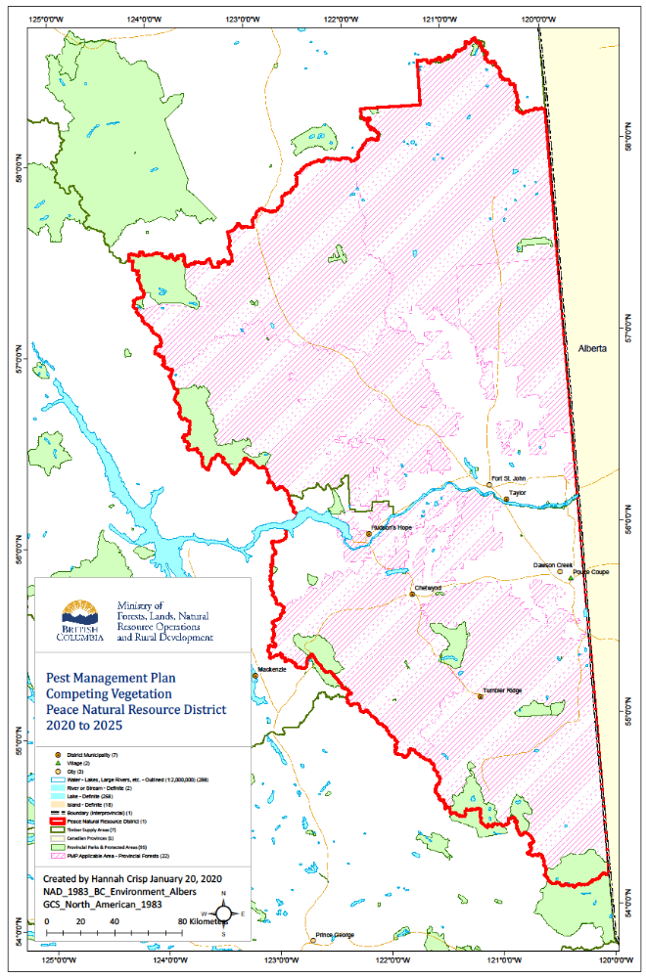

Appendix 2: Detailed Site Assessment Form

OPENING IDENTIFICATION & LOCATION
Disturbance Details:  (e.g. wildfire in FG plantation) | Click here to enter text.
Opening Number: | Click or to enter text. |  | Not applicable ☐
Polygon ID: | Click here to enter text. |  | Not applicable ☐
Timber Supply Area: | Choose an item. | Geographic Location: | Click here to enter text.
Access: | Choose an item. | Add access details here
Latitude: | Click here to enter text. | Longitude: | Click here to enter text.
Gross Opening Area (ha): | Click here to enter text. | Stratum: | Click here to enter text.
Stratum Area (ha): | Click here to enter text. | Treatment Area (ha): | Click here to enter text.
PROPOSED TREATMENT
Treatment Method: | Choose an item. | Proposed Timing: | Click here to enter a date.
Objective: | Click here to enter text.
PCP Number: | Click here to enter text. | Product Trade Name: | Click here to enter text.
Active Ingredient: | Click here to enter text. | Application Rate (L/H): | Click here to enter text.
Current Issues: | Click or tap here to enter text.

SITE HISTORY
Disturbance Date: | Click to enter a date. | Harvest History (NA ☐) |  |  | Click or tap to enter a year
Site Preparation (NA ☐) | Click to enter a year. |  |  | Add site prep method here
Planting (NA ☐) | Click to enter a year |  |  | White Spruce ☐  Hybrid Spruce ☐  Lodgepole Pine ☐  Other: Add other species here
Fill Planting (NA ☐) | Click to enter a year |  |  | White Spruce ☐  Hybrid Spruce ☐  Lodgepole Pine ☐  Other: Add other species here
Stand Tending (NA ☐) | Click to enter a year |  |  | Add stand tending method here
Previous Treatment(s) (NA ☐) | Most recent treatment date |  | Method: |  |  | Click here to enter text.
Previous Treatment(s) (NA ☐) |  |  | Application Rate (L/H): |  |  | Click here to enter text.
Previous Treatment(s) (NA ☐) | Purpose: |  | Choose an item |  |  | Notes

STOCKING
Inventory Component: | Click here to enter text. | Silviculture Component: | Click here to enter text.
Conifers/Ha: | Click here to enter text. | Deciduous Stems/Ha: | Click here to enter text.
Av. Crop Tree Ht. (m): | Click here to enter text. | Av. Decid. Tree Ht (m): | Click here to enter text.
Well Spaced Stems/ha: | Click here to enter text. | Date of Stocking Info: | Click or tap to enter a date.

SITE CHARACTERISTICS
BEC Zone/Var/Site Series: |  | Click here to enter text. |  |  |  | Moisture/Nutrient Regime: |  |  |  | Click here to enter text.
Elevation (m) |  | Click here to enter text. |  |  |  | Slope (%): |  |  |  | Click here to enter text.
Aspect: |  | Click here to enter text. |  |  |  | Topography: |  |  |  | Click here to enter text.
Dead Standing Trees (#/ha): |  | Click here to enter text. |  |  |  | Live Standing Trees (#/ha): |  |  |  | Click here to enter text.
Physical Factors Affecting Treatment: |  | Click here to enter text.
STREAMS, WETLANDS AND LAKE AREAS:
Type | PFZ (m) |  | Buffer (m) |  | Dry |  | NTZ (m) |  | Comments
Choose an item. |  |  |  |  | Y/N
Choose an item. |  |  |  |  | Y/N
Choose an item. |  |  |  |  | Y/N
Choose an item. |  |  |  |  | Y/N
Choose an item. |  |  |  |  | Y/N
Other Resources: | Beavers  Yes☐ No☐ |  |  | Nests  Yes☐ No☐ |  |  |  | Mineral Licks  Yes☐ No☐ |  |  | Stakeholders  Yes☐ No☐
Comments: | Click or tap here to enter text.

COMPETING VEGETATION
Species | Click here to enter text. | Click here to enter text. | Click here to enter text.
Cover (%) | Click here to enter text. | Click here to enter text. | Click here to enter text.
Av. Height (m) | Click here to enter text. | Click here to enter text. | Click here to enter text.
Range Height (m) | Click here to enter text. | Click here to enter text. | Click here to enter text.
Vegetation Pattern | Choose an item. | Choose an item. | Choose an item.
Structure | Choose an item. | Choose an item. | Choose an item.
Present Risk | Click here to enter text. | Click here to enter text. | Click here to enter text.
Future Risk | Click here to enter text. | Click here to enter text. | Click here to enter text.

CONDITION OF CROP TREES
Species | Choose an item. | Choose an item. | ☐Other: Click here to enter text.
Health | Choose an item. | Choose an item. | Choose an item.
Age | Click here to enter text. | Click here to enter text. | Click here to enter text.
Height (cm) | Click here to enter text. | Click here to enter text. | Click here to enter text.
Diameter (mm) | Click here to enter text. | Click here to enter text. | Click here to enter text.
Quality Issues | ☐ Chlorosis (c)  ☐ Uneven Crown (u)  ☐ Crooked Stem (s)  ☐ Stunted Leader (l)  ☐ Other: Click here to enter text. | ☐ Chlorosis (c)  ☐ Uneven Crown (u)  ☐ Crooked Stem (s)  ☐ Stunted Leader (l)  ☐ Other: Click here to enter text. | ☐ Chlorosis (c)  ☐ Uneven Crown (u)  ☐ Crooked Stem (s)  ☐ Stunted Leader (l)  ☐ Other: Click here to enter text.
Comments | Click here to enter text. | Click here to enter text. | Click here to enter text.

